RFID Based Campus Card System


Salah Ud Din Sheikh Muhammad Tahir

Supervised By
Dr. Junaid Tariq

Submitted for the partial fulfilment of BS Computer Science degree to the Faculty of Engineering & CS

DEPARTMENT OF COMPUTER SCIENCE
NATIONAL UNIVERSITY OF MODERN LANGUAGES RAWALPINDI

December, 2025

CERTIFICATE

Dated:

Final Approval

It is certified that the project report titled ‘RFID Based Card System’ submitted by
Salah Ud DIn, and Sheikh Muhammad Tahir for the partial fulfillment of the requirement of “Bachelors Degree in Computer Science” is approved

COMMITTEE

Dr. FirstName LastName

Dean Engineering & CS Signature:

Dr. Basit Shahzad

HoD Engineering Signature:

FirstName LastName

Head Project Committee Signature:

FirstName LastName

Supervisor Signature:
ABSTRACT

The rapid digitalization of educational institutions has created a demand for unified, secure, and automated systems to manage diverse campus operations. Traditional manual methods for attendance marking, library management, and cash-based cafeteria transactions are often prone to errors, time-consuming, and lack real-time data transparency. This project presents a Smart RFID-Based Campus Management System, an integrated Internet of Things (IoT) and web-based solution designed to modernize university infrastructure through a single-card identity.

The system is architected using a robust MERN stack (MongoDB, Express.js, React.js, and Node.js) for the centralized cloud backend and administrative portals, while the localized hardware terminals are powered by Raspberry Pi 4 units running custom Python logic. By utilizing MFRC522 RFID sensors, the system facilitates five core modules: automated class attendance, a digital e-wallet for cashless cafeteria payments, library book issuance, transport eligibility validation, and secure campus entry. A key feature of the implementation is the use of WebSockets (Socket.io) to provide administrators with instantaneous data synchronization and live monitoring across all terminals.

Systematic testing and performance analysis demonstrated a high-speed response time, with transaction and logging events finalized in under 1.5 seconds. The results confirm that the system effectively ensures data integrity, prevents unauthorized access, and eliminates the logistical bottlenecks associated with manual record-keeping. Ultimately, this project provides a scalable and cost-effective framework for transforming traditional campuses into "Smart" environments, enhancing operational efficiency for both students and university administration.

DECLARATION

We hereby declare that our dissertation is entirely our work and genuine/original. We understand that in case of discovery of any PLAGIARISM at any stage, our group will be assigned an F (FAIL) grade and it may result in withdrawal of our Bachelor's degree.

Group Members Signatures

- Salah Ud Din

- Sheikh Muhammad Tahir

PLAIGRISM CERTIFICATE

This is to certify that the project entitled “RFID Based Card System”, is being submitted here for the award of the “Degree of Bachelor” in “Computer Science”. This is the result of the original work by Salah Ud Din, and Sheikh Muhammad Tahir under my supervision and guidance. The work embodied in this project has not been done earlier for the basis of the award of any degree or compatible certificate or similar title of this for any other diploma/examining body or university to the best of my knowledge and belief.

Supervisor Name

TABLE OF CONTENTS
Contents
DEPARTMENT OF COMPUTER SCIENCE 1
Chapter 1 1
INTRODUCTION 1
1.1 Introduction 2
1.2 Motivation 2
1.3 Problem Statement 2
1.3 Goals and Objectives 2
1.4 Scope of the study 3
1.6 Process model 3
1.7 Nature of the project 3
1.8 Overview/Organization of the report 3
Chapter 2 5
BACKGROUND AND EXISTING SYSTEMS 5
2.1 Introduction 6
2.2 Explanation of Important Constructs 6
2.3 Existing Studies/Systems 6
2.4 Comparison of Existing Systems 6
2.5 Summary 7
Chapter 3 8
Requirements Specification 8
3.1 Introduction 9
3.2 Interface Requirements 9
3.3 Functional Requirements (By Module) 9
3.4 Use Case Model 11
3.5 Use Cases (Description) 12
3.6 Non-Functional Requirements 18
3.7 Resource Requirements 18
3.8 Database Requirements 19
3.9 Project Feasibility 19
3.10 Summary 20
Chapter 4 21
SYSTEM MODELLING 21
4.1 Introduction 22
4.2 System Design 22
4.3 Design Approach 22
4.4 Interface Design (High Fidelity Prototype) 22
4.5 4+1 View Model of Architecture 23
4.6 Entity Relationship Diagram 37
4.7 Summary 38
Chapter 5 39
IMPLEMENTATION 39
5.1 Introduction 40
5.2 Technical Stack and Development Environment 40
5.3 Implementation of Software Modules and Algorithms 40
5.4 Hardware Implementation and Configuration 42
5.5 Interface Implementation (GUI) 42
5.4 Summary 43

LIST OF TABLES

Table 2-1 Comparison of Existing Systems 6
Table 3-1- Use Case 1: Mark Attendance 12
Table 3-2 Use Case 2: Issue/Return Book 12
Table 3-3 Use Case 3: Cafe Payment (E-Wallet) 13
Table 3-4 Use Case 4: Bus Entrance Validation 14
Table 3-5 Use Case 5: University Entrance Security 15
Table 3-6 Use Case 6: Manage Student Accounts 15
Table 3-7 Use Case 7: Add Funds to E-Wallet 16
Table 3-8 Use Case 8: Manage Book Inventory 17
Table 3-9 Use Case 9: Monitor System Activity 17
Table 6-1 Test Case 1 User Authentication 46
Table 6-2 Test Case 2 Attendance 46
Table 6-3 Test Case 3 Positive Transaction 47
Table 6-4 Test Case 4 Transaction Negative 48
Table 6-5 Test Case 5 Transport Validation 48
Table 6-6 Test Case 6 Book Issue/Return 49
Table 6-7 Real Time Sync(Admin Side) 50

TABLE OF FIGURES

Figure 3-1 Use Case Model 11
Figure 4-1 Class Diagram 23
Figure 4-2 Activity Diagram 25
Figure 4-3 State Diagram 27
Figure 4-4 Sequence Diagram(Café Payment) 29
Figure 4-5 Sequence Diagram(attendance) 31
Figure 4-6 Component Diagram 32
Figure 4-7 DFD level 0 33
Figure 4-8 DFD level 1 34
Figure 4-9 Deployment Diagram 35
Figure 4-10 Entity Relationship Diagram(DFD) 37

Chapter 1

INTRODUCTION

Introduction

In today's universities, administrative tasks like keeping track of student attendance, managing the library, and controlling access are still mostly done by hand or with old, broken systems. These old-fashioned ways are often not very effective, are easy to make mistakes with, and take a lot of time for both students and university staff. As technology has gotten better, especially in the areas of the Internet of Things (IoT) and smart card-based authentication, it has become clearer that we need automation. This project entails the proposal, design, and development of a tangible and significant initiative pertaining to Computer Science. The goal of the project is to create an RFID-based Campus Card System that uses IoT, RFID technology, a touchscreen interface, and a full web dashboard to automate many university tasks. The suggested system lets students check in, pay their bills, borrow library books, and check their entrance and transportation status all with one RFID card. This system is meant to make things run more smoothly, make things safer, and make sure that everyone on campus has a great experience.

Motivation

The main goal of this project is to get rid of the "Proxy Culture" and "Cash Dependency" that are common on college campuses. Students can mark their presence for absent classmates on manual attendance registers, which is called proxy attendance. Also, cash handling in cafeterias slows down service and makes things harder for the staff. Also, the fact that there is no real-time verification for transport and gate entry is a big security risk. The project encourages a move toward a secure, digital, and efficient "Smart Campus" by bringing these services together on one smart card. This project fits the requirement that the proposal should map at least one Sustainable Development Goal (SDG).

1.3 Problem Statement

Many colleges and universities still use old systems, require cash payments, and have poor library management, which causes a lot of problems. There is a lot of attendance fraud in classrooms because there is no Smart Monitoring. There are security risks because there is Smart Tracking for students. Students often say that carrying cash for university services is dirty and hard to do. Lastly, the fact that library, transportation, and finance systems don't work together leads to duplicate data and mistakes in operations.

1.4 Goals and Objectives

The main goal is to use RFID and IoT logic to create a central verification system. One goal is to use a secure hardware terminal to automatically log attendance. Another goal is to use smart tagging to make it easier for people to check out and return books at the library. The system also wants to set up a safe "Tap-to-Pay" e-wallet for the cafeteria. Also, the system will check student bus passes right away when they get on the bus using portable terminals. Lastly, the project wants to make sure that only authorized people can get into the university by checking their identities digitally.

1.5 Scope Of Study

A tiny computer called Raspberry Pi powers what they call a Universal Verification Terminal. In one mode it checks who shows up, recording when and where each student is seen. Instead of paper rolls, attendance gets saved digitally with exact timing. Another function handles library books - keeping tabs on loans plus reminding about return deadlines. When students grab lunch, the machine pulls money straight from their stored balance. Payment happens fast, no waiting. Riding the bus means showing access rights based on paid fees and assigned routes. Each purpose runs separately but shares the same core device. Most times, the campus access check runs quietly behind the scenes. Entry approval shows up on a monitor instead and he/she is authorized access will be granted and vise versa. Screen-based confirmation helps staff decide who gets through. The setup tracks current student status mainly for audit trails. No mechanical triggers happen when verification completes. Human eyes review the data before allowing passage. Digital signals stay confined to displays, not hardware controls. Access relies on visual cues rather than automated barriers. System feedback appears in interface windows only.

1.6 Process model

This project uses the Agile Incremental Model. Because IoT work mixes hardware and software - both tricky to sync - a step-by-step method makes sense. Instead of waiting until everything is built, developers start with basic validation features right away. Then, module by module, new pieces get woven into the system over time. Each phase delivers something working, so testers can check progress early and often. Progress shows clearly at each turn, no guesswork needed. Stability grows piece by piece while adjustments fit naturally into the flow.

1.7 Nature of the project

Out there among smart gadgets and thinking machines, this one lives at the crossroads of real-world sensing and digital brains. Running on a tiny but tough computer - like a Raspberry Pi - it pulls in signals from its surroundings using RFID card reader. With everything tied together, raw inputs turn into something meaningful without extra help.

1.8 Overview/Organization of the report

Seven parts shape how the story unfolds across this document. After setting context early on, chapter two looks at what came before. Requirements come alive in the third section, showing each module's needs. Structure takes form when diagrams enter the frame near the middle. Further along, choices made during building appear clearly laid out. Each step follows its own rhythm, yet fits within the whole. Details emerge slowly, like layers peeling back under light. Results show up in chapter six, along with tests and how things were checked. Wrapping it all up, chapter seven shares what was learned plus ideas that might come next.

Chapter 2

BACKGROUND AND EXISTING SYSTEMS

2.1 Introduction

Starting off, the background and earlier efforts lay out core ideas behind campus automation alongside today's tech setup. Instead of separate systems, it looks at how transport, shopping areas, and libraries handle ID checks right now. One idea builds on another, showing ways to pull those methods into one smooth university network. Rather than sticking with scattered processes done by hand, the goal shifts toward a single digital system. Through updated messaging formats and smarter handling of information, student interactions become more seamless. Each part connects, aiming to simplify access while relying less on outdated routines.

2.2 Explanation of Important Constructs

Built into this system are several core parts, each needing clear insight into how they actually work. Starting with the Smart Card - it uses RFID tech to send data without touching anything, holding just one ID per device. MIFARE 1K tags operate at high frequency here, chosen because they tend to stay secure and keep working over time. Then there's the E-Wallet, acting like an online money space where funds live as protected numbers inside a main storage hub instead of cash. Checking a digital ID means matching it instantly against stored records to see what someone can do. A system looks up details like whether overdue fines are paid, if they’re currently enrolled, or if they may borrow books. What shows up depends on live data pulled the moment the scan happens. Permissions change only when information behind the scenes updates first.

2.3 Existing Studies/Systems

Old software handling college jobs usually runs alone, using outdated rules that cause clear problems. Libraries stuck in the past lean on barcodes - these need exact sight to work, stop reading when smudged or torn. Public transport like metros uses RFID tags now, yet those tend to cost too much, lock users into one brand, stay cut off from school records or book checkouts. Security at campus entrances? Often just guards eyeballing stiff plastic IDs. Mistakes happen fast this way. Fakes slip through. Lines stretch out when crowds surge. No live log tracks who came and went.

2.4 Comparison of Existing Systems

Table 2.1 provides a detailed comparison between manual systems, barcode systems, and the proposed integrated RFID system.

Table 2-1 Comparison of Existing Systems
Feature | Manual System | Barcode System | Proposed Integrated System
Modules Covered | Single (Isolated) | Single (Library only) | All 5 (Attendance, Bus, Cafe, etc.)
Security Level | Low (Visual check) | Medium | High
Processing Speed | Slow (>10 sec) | Medium (5 sec) | Fast (<2 sec)
Data Centralization | No (Separate registers) | Yes | Yes (One Central Database)

2.5 Summary

These days, campus tools mostly operate apart, rarely connecting smoothly. While individual devices manage specific tasks well, they don’t communicate - leading to cluttered forms and annoyed people. A single ID card might fix this by handling several roles: identity proof, book loans, bus access, meal payments. Rather than bouncing between platforms, all functions unite in one place. Fewer pieces to handle means things run smoother. With control tucked into a single spot, rather than stretched across many, risks drop without extra effort.

Chapter 3

REQUIREMENT SPECIFICATIONS

3.1 Introduction

What lies inside the requirements chapter shapes how the campus card system using RFID must behave and what limits it faces. Hardware and software links come next, spelled out clearly so nothing gets missed later on. Each of the five working parts carries specific duties, all laid bare here without extra noise. Performance rules that aren’t about function still matter just as much - speed, access control, reliability. A full picture emerges, built not for show but to match real demands across campus. Technical clarity keeps things moving when decisions need grounding in facts.

3.2 Interface Requirements

Communication between parts of the system depends on specific rules being followed. When pieces must connect, certain conditions become necessary. These conditions ensure smooth interaction across elements. Without meeting them, the full setup cannot work properly. Each requirement acts like a bridge for data flow. The entire structure relies on such links to function as one.

3.2.1 Hardware Interface

Pieces of hardware link real-world actions to digital signals through distinct parts. Instead of just wires, the setup uses an MFRC522 chip to read RFID tags by talking to the Raspberry Pi 4 Model B over SPI lines on its GPIO ports. Information appears on a small screen - exactly 5 inches - with visuals sent using another SPI path directly to the display unit. Since some pieces must move freely during testing, the whole thing runs off a alternating current(A.C).

3.2.2 Software Interface

A control panel for admin sits alongside a student area, each made with React.js so records stay in one place while personal logs remain separate. From the Raspberry Pi, a desktop-style app runs on Python, styled with CustomTkinter to work smoothly when tapped. Instead of direct links, messages travel between devices and main system via a REST API coded in Express.js. Information does not vanish; it lives in MongoDB Atlas, a flexible database keeping updates live across all points.

3.3 Functional Requirements (By Module)

The functional requirements are categorized by the five core modules that define the system's operation.

3.3.1 Module 1: Class Attendance

Every time a student taps their RFID card, the machine grabs the unique ID right away. Once it has that number, checking if the student is enrolled happens instantly. When confirmed, the record updates to show “Present,” stamped exactly when it happened. Right after, the screen lights up with a clear sign and words saying it worked.

3.3.2 Module 2: Library Management

Scanning begins with the Book ID, followed by the student card. Once both are read, the connection forms between that book and the borrower. This pairing gets stored in the issued records. At the same time, the book marks itself as borrowed. A clear notice appears afterward. Due date shows up there too, worked out by set rules.

3.3.3 Module 3: Cafe Payments

Should the student's wallet hold enough money, the system checks it against what staff enter. When there is enough, out goes the sum from their account. Their updated total then saves into storage. A record of this move also logs separately.

3.3.4 Module 4: Bus Entrance

Checking happens first - whether the pupil's name appears on a set bus path, along with current travel approval. Only then does the screen show if access is allowed, right where the driver can see it when students climb aboard. A green signal means go, shown clearly before the door shuts behind them. No match or expired tag brings up a halt notice instead, flashing just once. Each check runs fast, tied to live data, so delays stay rare even at peak hours. The moment someone steps onto the vehicle, their trip record updates silently. Old records drop off automatically when new routes assign through admin input. Even offline moments keep working - the device stores results until connection returns. What matters most shows upfront: ride permission, clear and unmissable. Behind that front layer, timestamps lock in place with every scan made. Drivers rely on this flow because surprises rarely surface mid-route now. Every detail stays fixed unless changes come from authorized staff only. Updates appear instantly across devices once confirmed in central tracking. Riders get no extra messages; they watch the light like everyone else. Silent checks repeat each day without needing reminders or manual restarts.

3.3.5 Module 5: University Entrance

At times, the setup must confirm a student’s standing - only allowing those marked Active instead of suspended or removed. Following that step, it records when someone enters so there’s a record for safety checks later. Then, what shows up on screen switches between “Access Granted” or “Access Denied,” giving guards something clear to see while watching entry points.

3.4 Use Case Model
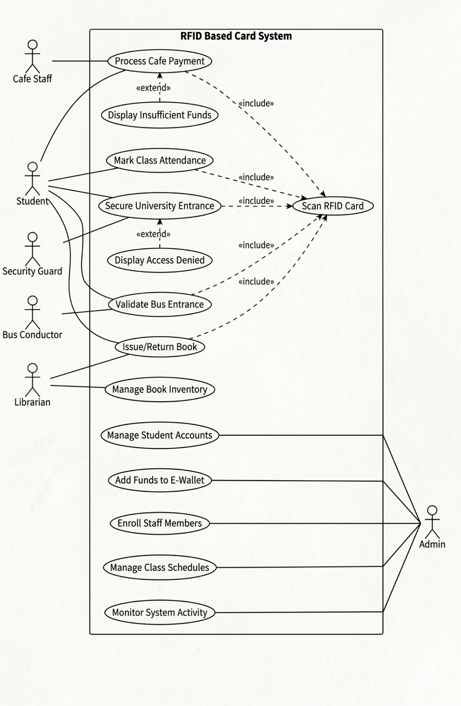
Figure 3-1 Use Case Model

3.5 Use Cases (Description)

3.5.1 Use Case 1: Mark Attendance

Table 3-1- Use Case 1: Mark Attendance
Field | Description
Use Case Name | Mark Class Attendance
Primary Actor | Student
Pre-condition | Student is registered in the system and the class session is active in the database.
Basic Flow | 1. Student taps RFID card on the terminal.  2. System captures the card's Unique Identifier (UID).  3. System verifies student enrollment status against the active session.  4. System marks the student as "Present" in the database.
Post-condition | Attendance log is created with a precise timestamp.

3.5.2 Use Case 2: Issue/Return Book

Table 3-2 Use Case 2: Issue/Return Book
Field | Description
Use Case Name | Issue/Return Book
Primary Actor | Librarian and Student
Pre-condition | Student possess a valid account and has no overdue fines.
Basic Flow | 1. Librarian selects "Issue Mode" on the terminal.  2. Student scans RFID card to authenticate identity.  3. Librarian scans the RFID tag of the book.  4. System links Book ID to Student ID in the issued books collection.
Post-condition | Book status is updated to "Borrowed" in the database.

3.5.3 Use Case 3: Cafe Payment (E-Wallet)

Table 3-3 Use Case 3: Cafe Payment (E-Wallet)
Field | Description
Use Case Name | Process Cafe Payment (E-Wallet)
Primary Actor | Cafe Staff and Student
Pre-condition | Student must have sufficient balance in their digital wallet.
Basic Flow | 1. Staff enters the transaction amount.  2. Student taps RFID card to authorize payment.  3. System queries database to verify wallet balance.  4. System deducts funds and displays "Transaction Successful".
Post-condition | Student balance is updated, and a transaction log is recorded.
.

3.5.4 Use Case 4: Bus Entrance Validation

Table 3-4 Use Case 4: Bus Entrance Validation
Field | Description
Use Case Name | Validate Bus Entrance
Primary Actor | Student and Bus Conductor
Pre-condition | Student has paid the transport fee for the current semester.
Basic Flow | 1. Student taps card on the bus terminal during boarding.  2. System checks transport status and assigned route ID.  3. System displays "Valid Pass" or "Expired" result on screen.
Post-condition | Boarding timestamp is logged for management analysis.

3.5.5 Use Case 5: University Entrance Security

Table 3-5 Use Case 5: University Entrance Security
Field | Description
Use Case Name | Secure University Entrance Security
Primary Actor | Student and Security Guard
Pre-condition | Student must be currently enrolled with an active status.
Basic Flow | 1. Student taps card at the main gate terminal.  2. System verifies active enrollment and administrative status.  3. System displays access result for visual verification by the guard.
Post-condition | Entry log is created for security auditing.

3.5.6 Use Case 6: Manage Student Accounts

Table 3-6 Use Case 6: Manage Student Accounts
Field | Description
Use Case Name | Manage Student Users
Primary Actor | Administrator
Pre-condition | Admin is logged into the secure web portal.
Basic Flow | 1. Admin navigates to the User Management dashboard.  2. Admin searches for a student by Name or Registration Number.  3. Admin modifies student status (e.g., Active to Suspended).  4. System validates and commits changes to the database.
Post-condition | Student access rights are immediately updated across all terminals.

3.5.7 Use Case 7: Add Funds to E-Wallet

Table 3-7 Use Case 7: Add Funds to E-Wallet
Field | Description
Use Case Name | Add Funds to E-Wallet
Primary Actor | Administrator
Pre-condition | Admin is logged into the financial module.
Basic Flow | 1. Admin searches for student profile.  2. Admin inputs the top-up amount.  3. System verifies transaction and updates walletBalance.
Post-condition | Updated balance is reflected in the student's portal.

3.5.8 Use Case 8: Manage Book Inventory

Table 3-8 Use Case 8: Manage Book Inventory
Field | Description
Use Case Name | Add/Update Books
Primary Actor | Administrator
Pre-condition | Admin has metadata for new library items.
Basic Flow | 1. Admin navigates to the Library Inventory tab.  2. Admin enters Title, Author, and unique RFID Tag ID.  3. System records entry in the Books collection.
Post-condition | Book becomes immediately available for issuance in the library.

3.5.9 Use Case 9: Monitor System Activity

Table 3-9 Use Case 9: Monitor System Activity
Field | Description
Use Case Name | View Reports
Primary Actor | Administrator
Pre-condition | System has accumulated data from terminal logs.
Basic Flow | 1. Admin selects report category (e.g., Daily Attendance).  2. Admin specifies date range.  3. System queries logs and visualizes data in charts or tables.
Post-condition | Admin views insights or exports data as PDF/CSV for auditing.

3.6 Non-Functional Requirements

To work well, the system follows strict rules about quality and speed so users get reliable results every time. Because delays cause problems in busy spots like campus gates or cafeterias, each check at a terminal finishes under two seconds. Fast responses happen thanks to smart coding that lets the Raspberry Pi talk smoothly with the Express.js server using background tasks. When it comes to ease of use, the small screen built into terminals keeps things simple on purpose - especially for people who aren’t tech experts. Colors guide understanding instantly: green means yes, red signals no or something went wrong. Staff see these shades and know what they mean right away, even if they do not read anything else on display. Right away, any change shows up everywhere. When a student adds funds in the admin building, the number jumps on every screen at once. Thanks to MongoDB Atlas sitting at the center, nothing lags behind. Balance shifts appear fast - so buying lunch right after works without delay. Campus gadgets all pull from one source, keeping numbers in step. If something updates in one spot, it settles into all others like clockwork.

3.7 Resource Requirements

Putting together the project the right way means lining up certain tools, programs, and people just so. At its core sits a Raspberry Pi 4 Model B - handling all main computing tasks for the smart terminal setup. Connected to it, an MFRC522 RFID reader handles touch-free card scanning during use. A 5-inch TFT display joins the mix, showing visuals clearly through the user interface layer. Since the system needs to work at bus entrances freely, movement matters - so a large power bank keeps everything running without wall plugs. Built with up-to-date tools meant to grow, the system runs on Python 3 for its terminal part, styled neatly through CustomTkinter. Instead of a browser window, users interact via this desktop-style screen designed for clarity and ease. On the web side, both admin and student areas come alive using React.js - snappy interfaces shaped around user actions. Meanwhile behind the scenes, Node.js teams up with Express.js to manage how requests flow and respond. Data finds its home in MongoDB Atlas - a flexible cloud database chosen for handling varied information smoothly. People working on it split responsibilities not randomly but by what each does best. One person focuses on linking physical sensors, another shapes server functions, someone else crafts dashboards. Because work flows in small steps, testing happens early and often without waiting till the end. Progress moves forward piece by piece, matching how real needs unfold over time. Each chunk gets reviewed before moving ahead, keeping mistakes low and learning high.

3.8 Database Requirements

Storage rules demand the setup keep information accurate inside a NoSQL space so links between learners and their actions on campus stay reliable. MongoDB Atlas holds everything online, making sure updates show up instantly on every device - even those small computers placed around the library, dining spot, and school gates. Instead of lumping features together, each main task leans on its own dedicated part of the structure. Student details live mainly in one place called Users, where you will find ID codes, special tag identifiers from cards they tap, along with how much money sits in their digital wallets right now. Tracking who shows up when gets managed separately using Attendance_Logs, saving visits by class code plus exact clock time someone walks in. Transport checks rely on another segment named Bus_Routes, storing trip facts needed to confirm if a learner actually got on board correctly. Every now and then, the library module handles a Books group to keep track of item details. Instead of mixing data, it uses Issued_Books separately so loans connect each book to a student's ID clearly. At times, activity gets recorded only when needed through Transactions, which stores every e-wallet move across campus. Payments at cafes appear there along with refill entries plus past balance states. This way, money actions stay visible without gaps or confusion.

3.9 Project Feasibility

One reason people run a feasibility study? To see if a project fits inside real limits like schedule, money, and what tech is actually around. It checks if the RFID Based Campus Card System could really take shape at a university - working right, hitting goals, staying on track. What matters? Knowing it won’t fail before anyone lifts a finger.

3.9.1 Technical Feasibility

This project works because hardware and software team up to handle tasks without hiccups. A Raspberry Pi 4 pulls off the job just fine, even though it isn’t top-tier gear, running both the RFID reader and code smoothly. Instead of separate setups, one device covers five campus jobs thanks to how modes switch cleanly behind the scenes. No need for heavy machinery under the hood - lightweight tools do the lifting while staying dependable. Parts like MongoDB, Express, React, Node.js join forces with Python, forming a backbone that grows when needed.

3.9.2 Operational Feasibility

How well it works day to day depends on how smoothly tasks run behind the scenes. Because students already have ID cards, swapping them for smart RFID ones feels almost natural. Instead of complex steps, familiar routines help people accept the new system faster. Starting from login screens down to alerts, every visual detail follows human-centered design rules. Even someone who rarely uses computers can navigate without confusion. When one terminal changes a student's account balance, all others reflect it right away. This live sync means no delays or mismatched data between different campus spots. What happens here connects directly to real-time performance across locations. No waiting, just consistent updates wherever access points exist. Design choices shape behavior less when they match existing habits closely.

3.9.3 Legal & Ethical Feasibility

No laws get broken by this setup. Its purpose lives entirely inside helping people at the university. Harm to anyone using it cannot happen under how it works now. Down the road, faces might help unlock things - but right now access runs on RFID tags plus tight control over who sees what. Every piece of data, every dollar tracked, hides safe inside MongoDB Atlas, floating in the cloud where only approved parts of the system and staff can reach it.

3.10 Summary

Starting with how parts connect physically, the chapter lays out what machines must do alongside human workflows across five key areas. Not only does it show what tools are needed, but also how they work together under real campus conditions. Because every piece fits within practical limits, building the system stays realistic. Even when matching tech demands to school processes, balance guides each choice. So far, nothing goes beyond reach - each part stays grounded in daily use.

Chapter 4

SYSTEM MODELING

4.1 Introduction

Pictures drawn using UML show how the Smart RFID Campus System works inside and out. Instead of just describing parts, this section maps connections between software and hardware pieces. Because earlier sections listed what the system should do, here those ideas take shape in structured diagrams. With clear visuals, the jump from theory to actual build stays grounded in reason. A single main database holds everything together, handling many functions at once without breaking down..

4.2 System Design

From the start, one main database ties together each service on campus. Each device out there - a reader at dorm entry, a kiosk near food counters, or desks in admin halls - talks straight to that center hub. Instead of storing bits in separate spots, they pull fresh info whenever needed, then send changes back directly. When someone adjusts an account balance downtown in offices, those numbers shift everywhere else right after. Even the snack bar scanner sees it next time you tap your card.

4.3 Design Approach

Top-Down Approach: Starting at the top, the team built this system step by step. First came the main structure: user identity and database layout took shape early on. With login rules and data flow set in place, attention shifted outward. From that center, five pieces grew separately - Attendance, Library, Cafe, Bus, then Entrance. Each one ties back to the same base, working within shared rules. Because they stem from one source, repetition fades. All parts connect smoothly to the heart of the setup, avoiding duplicate effort. Consistency runs through each piece like a thread.

4.4 Interface Design (High Fidelity Prototype)

On first look, the layout makes it simple for admins and learners to move around without confusion. Tabs guide admin tasks - one for checking who showed up, another for money matters, books, or ride tracking. Over on the Raspberry Pi screen, what you see changes depending on which function is turned on. This shift happens smoothly thanks to a tool called CustomTkinter. When set to Café, numbers like current funds and how much was spent come front and center. Switching to Bus flips the view toward journey codes and whether passes are still good.

4.5 4+1 View Model of Architecture

4.5.1 Logical View (Class Diagram)

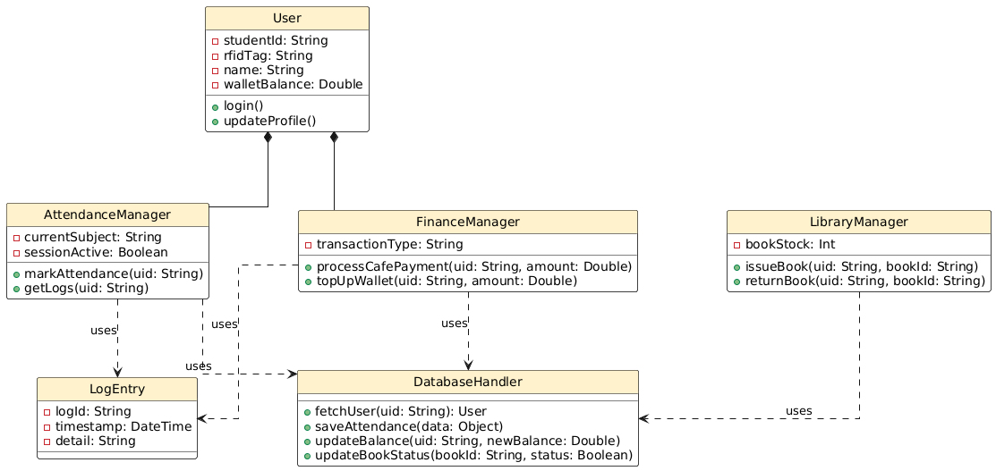
Figure 4-1 Class Diagram
Shown in Figure 4.1, the Class Diagram outlines how the Smart RFID Campus System organizes its key parts using objects and their interactions. Sitting at the center stands the User class - this holds each student's details like studentId, RFIDTag code, along with walletBalance used during money-related actions. Linked directly to it are two main controllers: AttendanceManager and FinanceManager, joined not just loosely but through a strong composition bond. Because of this tie, those managers only exist meaningfully while a User stays active. Without a live User present, any attempt by FinanceManager to run processCafePayment fails instantly since there’s no profile to pull or adjust balance from.

Looking at how things are split up, functions stay clear from data storage tasks. Instead of mixing roles, AttendanceManager handles check-ins, FinanceManager deals with money moves, LibraryManager manages book lending - each focused on one job. These three connect outward, relying on something else when they need to store or grab info. A dotted line marked "uses" shows that link between each manager and a shared helper called DatabaseHandler. That middle piece talks directly to the database in the cloud, making sure nothing gets lost. It runs specific actions such as pulling user details, recording who showed up, or changing account totals. Behind the scenes, everything ties back to MongoDB Atlas through structured calls. Each step taken in the app leaves a trace there, kept in sync without overlap. Every move Managers make gets saved through a LogEntry class, each tagged with its own logId plus a timestamp - this builds a clear paper trail needed for school oversight. Structure matters here because adding fresh modules later won’t break what already works; they simply slide in as new managers, keeping user tools and data routines untouched.

4.5.2 Process View

4.5.2.1 Activity Diagram:
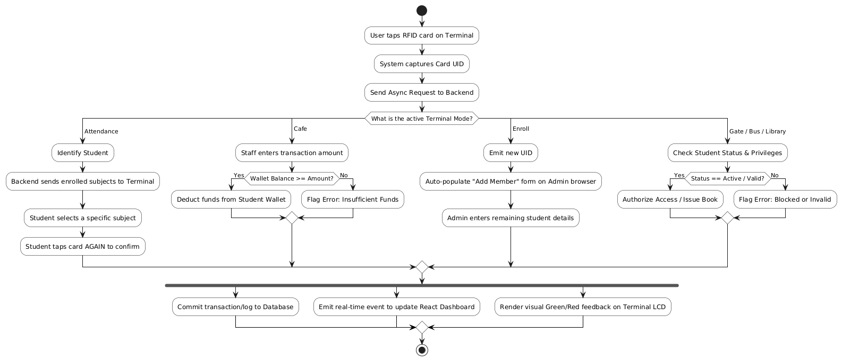
Figure 4-2 Activity Diagram
Figure 4.2 shows how the Smart RFID Campus System behaves while running, revealing its inner movement and decisions during an event's journey - starting at a person touching their card to a device, ending with what the system does next. A tap begins everything; contact between card and reader grabs the Card UID instantly. Speed matters here, so the device fires off data without waiting, sending it straight to the Express.js server. Once there, the setup checks which mode the terminal is using right now - that choice shapes what happens after. Depending on that setting, operations split into different paths, each tailored to fit exactly what the situation needs.

When using Attendance mode, the machine spots the student right away, pulling up which classes they’re signed into from stored records - that fills the screen with clickable options. To mark attendance, one choice gets picked, then the card goes back onto the reader, double-checking intent through a second tap. On the flip side, handling payments in Cafe mode means typing how much was spent, making the device test whether money inside the digital wallet covers the cost. Money enough? It subtracts silently. Not enough? A notice pops up saying there isn’t enough to go through. As doors or buses open, or books change hands in the library, checks happen behind the scenes - status lights turn green only when enrollment stays current and rights line up correctly ahead of any unlock or handout.

At the end, a sync bar pulls everything together when the module’s conditions line up. Only then does the system push data into MongoDB - recording either transactions or attendance logs at once. Right after, it sends an instant signal through WebSockets to refresh the Admin Dashboard built in React. Meanwhile, the terminal’s screen flashes a colored response without delay. Colors do the talking: green means go, red means stop. Users see results immediately, just as the design demands. No waiting. No guessing. Just fast clarity for both workers and operators. This tight loop meets core needs around speed and ease of use.

4.5.2.2 State Diagram:
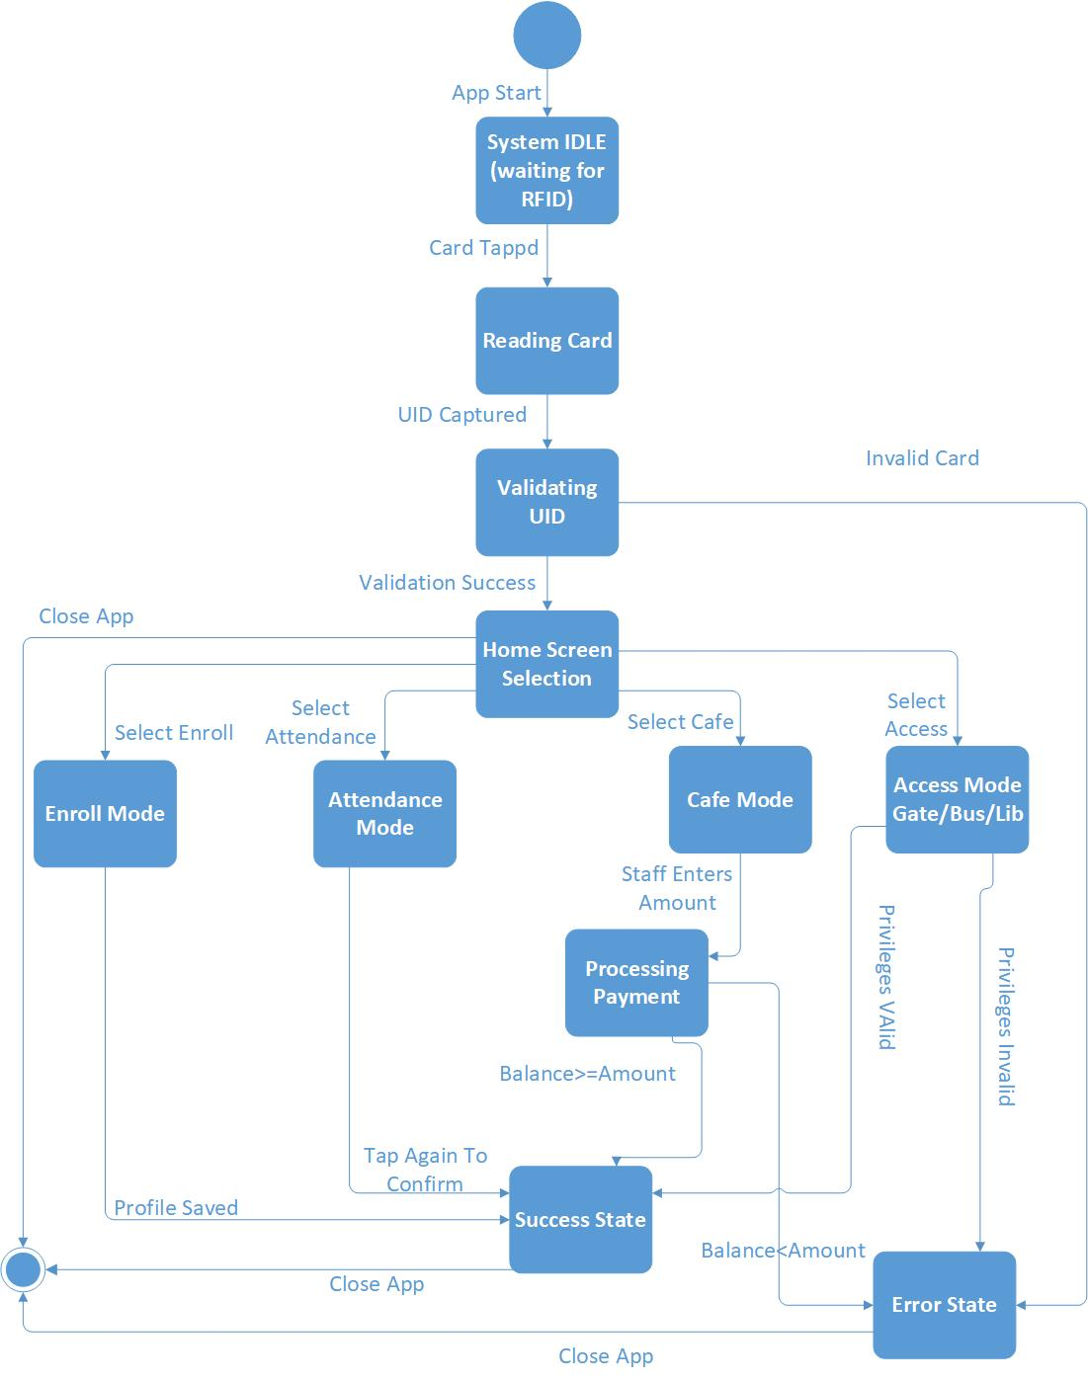
Figure 4-3 State Diagram

Figure 4.3 shows a map of states for the app built on Raspberry Pi. How it shifts between modes matters just as much as what those modes do. Started off doing nothing, that is when the software sits still - waiting. Only breaks silence once the RFID chip sends a signal. That snap of data pulls it into grabbing the tag’s identity code. Messed up reads send everything sideways - straight into failure mode. Back to quiet after that, like nothing ever happened.
Once captured, the app moves to Validating UID, reaching out via API to a Node.js backend that checks the tag against records in MongoDB. When confirmed, access opens to the Home Screen Selection - the main point for navigating campus functions. This screen acts like a starting post for different paths: Enroll Mode appears here, along with Attendance, Cafe, and Access Modes covering entry points like gate, bus, library. Inside each mode lives its own logic, tuned to what comes next - choosing a class during attendance, entering amounts when buying food. Every path waits for its proper signal before moving forward.
When the module logic finishes, that decides the last shift. Take Cafe Mode. It goes into Processing Payment. Should money be enough, it lands in Success. Not enough funds? Then off to Error it goes. Access Mode works much the same - valid access keeps things moving, broken permissions halt progress. Each path, win or fail, circles home - to either Final or back into IDLE, waiting quiet for the next person. Stability comes from these clear stages, each showing plain messages so users always know what happened.

4.5.2.3 Sequence Diagram:

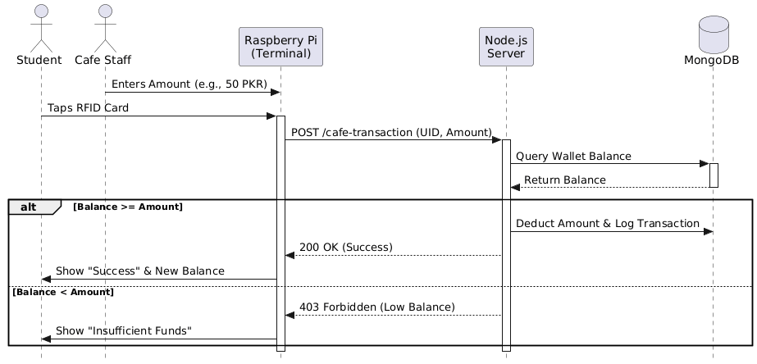
Figure 4-4 Sequence Diagram(Café Payment)
Figure 4.4 shows how parts of the system talk to each other when someone pays digitally at the campus cafeteria. Timing matters here - every step follows a clear order. Instead of starting with the student, it's actually the cafe worker who kicks things off by typing in the cost on the terminal. Only after that does the student approve the purchase, using an RFID card tap. Once tapped, the Raspberry Pi wakes up and fires off a safe, background message packed with the card ID and price. This message heads straight to the online backend through a POST call. On the receiving end are two pieces: a Node.js server ready to handle requests, plus a MongoDB database waiting to store records. People involved include both the student making the payment and the staff member running the sale. Communication links tie everyone and everything together across locations. Each move happens one after another, like steps down a path.

When the request arrives, the Node.js server takes charge right away. First it checks MongoDB to get how much money the student has now. Then comes a shift in path - one that depends on what number shows up from storage. If enough sits there - equal to or more than needed - the system removes cash while saving proof of move at once. A signal labeled 200 OK heads out toward device after that step completes. That message makes screen flip its words instantly - to say Success and display leftover sum clear to eye.

When the database shows low balance, the server skips taking money and sends back a "403 Forbidden" code instead. On getting this reply, the Raspberry Pi displays a message saying "Insufficient Funds," stopping any further steps. Only after checking live data does the system allow actions - this moment confirms everything aligns at once. In under two seconds, every part agrees: what happens here stays accurate there.

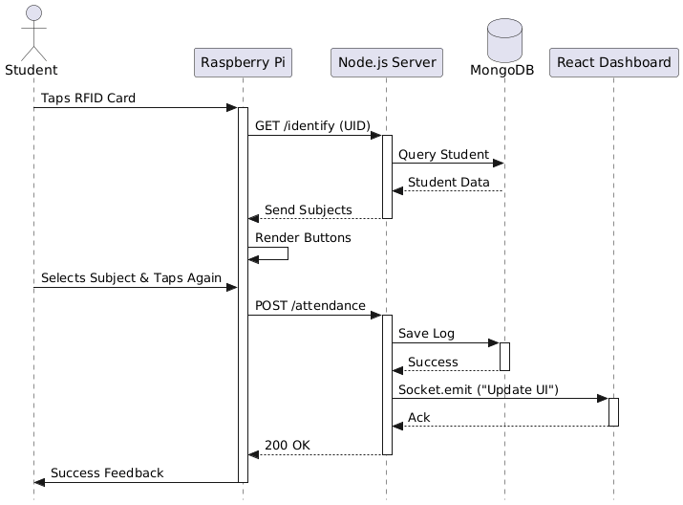
Figure 4-5 Sequence Diagram(attendance)
Figure 4.5 shows how the student interacts with different parts of the system during two-step verification for signing in. When the student taps their RFID card, that signal wakes up the Raspberry Pi; it then asks the Node.js server who this person is. Instead of guessing, the server checks MongoDB and pulls out the correct student record. Once confirmed, back comes a set of courses tied to them. These appear now as tap-ready options - laid out by the Python app using CustomTkinter - right there on the display screen attached to the device.

Picking a subject first, the student taps the card again to lock in the entry. A signal fires off after that second tap - this one heads straight to the server as a POST call. While the backend wakes up, two things happen at once behind the scenes. One path carves the check-in into the MongoDB storage space. At the exact same moment, another thread pushes a live alert through WebSockets. That alert reads “Update UI,” flashing toward the admin screen built with React. Only when both tasks report back does the system relax. The dashboard signals it refreshed, the database says data landed safely. Then - and only then - a green light flows back to the Raspberry Pi unit. Lights shift on the terminal front moments later. Feedback shows fast, clear, visible proof for the learner standing there. No gaps remain between device, server, and display - the stamp holds firm everywhere.

4.5.3 Development View (Component Diagram)
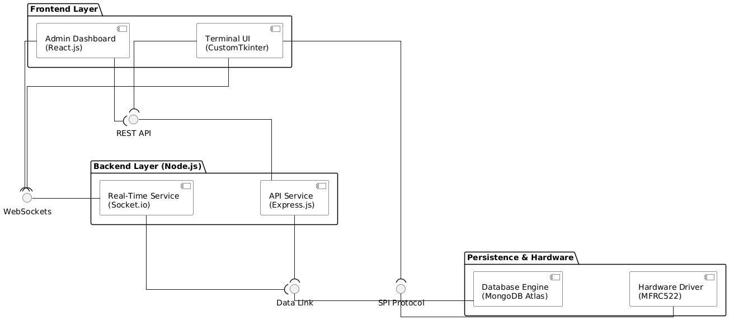
Figure 4-6 Component Diagram

Figure 4.6 shows the layout of the Smart RFID Campus System using a Component Diagram, giving a clear picture of how software pieces fit together and rely on each other physically. Built around three main parts - Frontend, Backend, and Persistence plus Hardware - the structure separates concerns across levels. Instead of blending functions, the Frontend holds two separate interfaces: one being the Admin Dashboard, made with React.js so staff can manage tasks online; the other, a Terminal UI running directly on Raspberry Pi devices using Python combined with CustomTkinter. Communication happens when these front-facing tools reach the backend by way of a consistent REST API, allowing loose coupling between layers.

Running on Node.js, the backend manages every part of the system from behind. One piece, the API Service, uses Express.js to deal with incoming requests and send back responses. Instead of waiting, actions happen right away thanks to the Real-Time Service, which relies on Socket.io. When someone taps an RFID card anywhere on campus, alerts fly instantly to the Admin Dashboard. That instant flow supports how the Smart Campus operates day to day. A fast data connection ties everything to the main database. Because of this link, each module sees updated student details without delay. Nothing lags. Everything stays in step.

Down at the base sits what keeps everything running - the place where information lands and real-world parts connect. Built into this level you will find the Database Engine, powered by MongoDB Atlas offering flexible NoSQL space up in the cloud. Tied alongside it lives the Hardware Driver made for the MFRC522 RFID reader, handling touchpoints between people and machines. Communication flows when the Terminal UI reaches out using the SPI Protocol, pulling unique IDs from cards swiped near the sensor. From that quick tap on a device all the way to an entry saved online, the path stays clear and direct. Because every piece fits together like building blocks, changes in one area won’t break another. Growth becomes possible without starting over, meeting both engineering needs and structure plans laid out early on.

4.5.4 DFD:

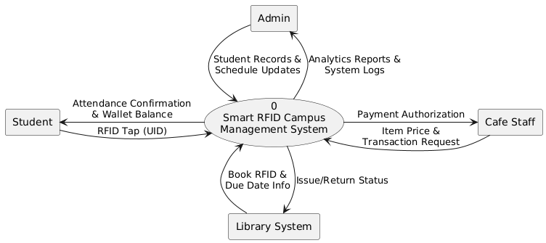
Figure 4-7 DFD level 0
Figure 4.7 shows the Context Diagram - also called DFD Level 0 - a broad view of the Smart RFID Campus Management System, drawing clear lines between internal operations and outside participants. One single process, labeled Process 0, stands at the center, capturing the entire system’s function in one shape. Data moves back and forth across these borders, fueling tasks tied to daily campus routines. Instead of breaking things into smaller parts, it focuses on how information travels at the highest level. Students interact directly, sending inputs like ID scans while receiving access updates in return. Admin personnel feed enrollment details into the system, also pulling reports when needed. Cafe Staff exchange meal purchase records, syncing balances through real-time transfers. Meanwhile, the Library System shares book checkout logs and gets updated user permissions instantly. Each connection marks a distinct flow of useful digital material. Together, they form a live network centered around one intelligent controller. This setup keeps every role linked without showing inner mechanics. Its simplicity reveals only what crosses the boundary, nothing more.
When a student taps their RFID card, it shares a unique ID with the system. After that comes instant feedback - attendance marked, wallet balance shown live. Instead of cash, cafeteria workers rely on price details sent in and get approval signals back fast. Books speak through RFID tags too, sharing check-in deadlines each time scanned. What follows? A clear go-ahead: borrowed or returned - the library knows right away. Out here, the Admin part handles everything - keeps student info up to date, adjusts schedules. At the same time, it pulls in big-picture summaries and log files just to keep tabs on how things run. The drawing shows something clear: one hub runs the whole show. Every bit of outside data flows into that core brain so every office on campus stays in sync. That’s how order sticks around.
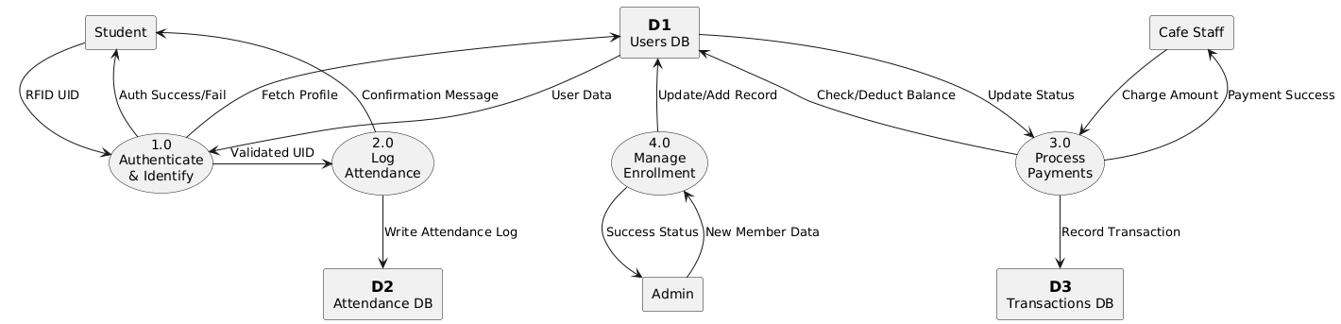
Figure 4-8 DFD level 1
Figure 4.8 shows a closer look at how the system works inside, going deeper than just the big picture by showing exactly how information moves and changes through separate functions. Instead of staying broad, it splits everything into four main actions: first comes Authenticate & Identify, followed by Log Attendance, then Process Payments, ending with Manage Enrollment. Stored data appears here too - three key spots named D1 Users DB, D2 Attendance DB, and D3 Transactions DB - all lining up with actual groups found in MongoDB Atlas. From the start, a Student gives an RFID UID; that kicks off authentication, triggering a check against the Users DB to pull up their details and confirm who they are before handing things over to what happens next.
Inside each system part, smaller tasks handle particular jobs. When someone shows up, their visit gets logged into a database while they get a note saying it was recorded. Right after that step finishes, money handling talks to cafeteria workers to find out costs; only when those numbers arrive does it look at the person's account, take funds if possible, then store details of what happened. People joining start with an admin typing information, leading straight to changes in the main collection of user profiles. Every move ties back to verified personal records so nothing runs without checks, keeping everything linked correctly throughout daily activities on site.

4.5.5 Physical View (Deployment Diagram)

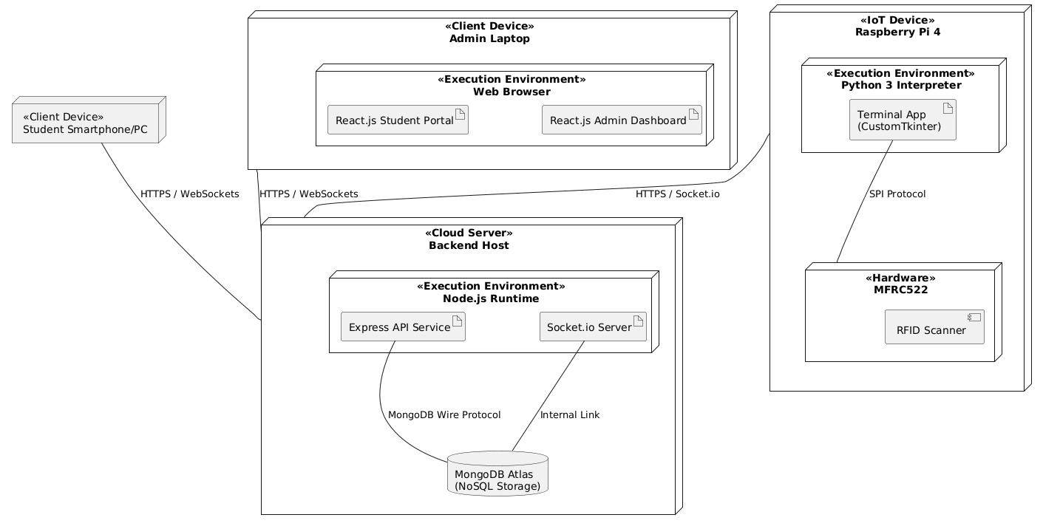
Figure 4-9 Deployment Diagram

Figure 4.9 shows how the Smart RFID Campus System connects software to real-world machines through its deployment layout. Instead of one central machine, work happens on three main devices: Raspberry Pi 4 units act as local sensors, a remote Cloud Server runs backend tasks, while separate gadgets - like admin laptops and student phones - access the system. Because computing power lives mostly in the cloud, yet readings happen right where tags are scanned, performance stays strong even as more users join. Physical touchpoints handle entry checks and signals up close; everything else gets managed far away but responds quickly. This split keeps operations stable, avoids overload, scales easily when needed, without relying on any single point.
Out there on the edge, the Raspberry Pi 4 runs everything by holding a Python 3 interpreter inside. Inside that setup, a tool called the Terminal App - built with CustomTkinter - handles how users interact locally and how it talks to connected parts. Instead of wireless tricks, a direct SPI link ties the app to an MFRC522 RFID scanner, catching each card swipe as it happens. From there, updates fly across the network: one path uses HTTPS for regular checks, another leans on Socket.io to keep contact alive and fast. That way, every tap and system note reaches the backend right away, no lag built in.
Running everything behind the scenes, the Backend Host lives inside a Node.js environment. Instead of sitting idle, it powers an Express API that handles core operations while running a Socket.io server to push live updates. Tied directly into this setup sits MongoDB Atlas, storing data without traditional tables. Communication with this database happens through the MongoDB Wire Protocol, keeping things linked. Over on user devices, whether desktop or mobile, web browsers load up two key interfaces: one for students, built with React.js, another for admins, using the same framework. Each piece works separately but stays connected at all times. Most of these users stay connected through secure links, getting live reports whenever someone clocks in or money moves. When one device goes down, another picks up the load - keeps everything running without a hitch. Cloud storage holds steady throughout, so data stays reachable regardless of local changes..

4.6 Entity Relationship Diagram

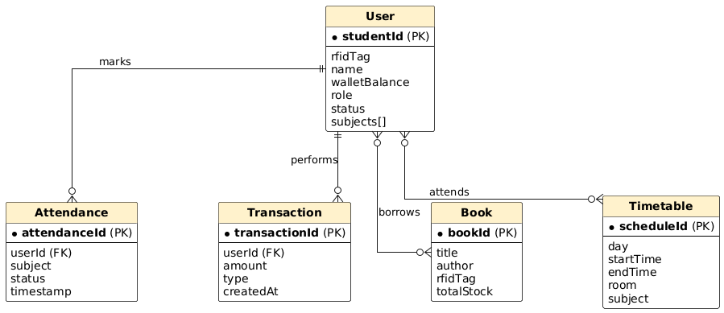
Figure 4-10 Entity Relationship Diagram(DFD)
Shown in Figure 4.10, the Entity Relationship Diagram maps out how data elements connect logically within the system, along with their relationship counts. Even though MongoDB - a NoSQL platform - is used here, this diagram outlines clear links ensuring consistent data handling throughout the five campus modules. Sitting at the core of the structure is the User entity, recognized mainly through its unique studentId key. All actions tied to students branch off from this central piece, storing critical details like RFIDTag for access checks and walletBalance that supports electronic payments. One student ties to many entries - crow's foot shows it. Logs pile up per pupil, yet every mark points to just one user ID. Money moves multiply under a sole account, each tied by a foreign link. Books shift hands through checkouts, always tracing back to a single borrower. Each action stands alone but roots into one identity. Multiple records grow from one source, never the reverse. A person spawns repeated events; each event names its owner once. No shared keys here - one user feeds varied histories. Every trace connects downward, never across or upward. Instances stack beneath an individual, only ever theirs.
Connections between teaching and office tasks show up clearly in the layout. From one angle, attendance ties into class schedules using an "attends" link, so check-ins happen only when a session is planned. A student grabs a book, that action forms a bond between borrower and item, logged under "borrows." Each copy in stock carries traits like RFIDTag and how many exist overall within the Book setup. Money movements appear via Transaction, holding unique IDs, sums involved, and whether money came in or went out. Wallet balances adjust based on past entries, each step saved for review later. Inside MongoDB, pieces stay aligned because structure splits data smartly across groups. Reports pull correct summaries since stored facts reflect real actions taken earlier. Design choices here answer what leaders need without extra clutter piling up.

4.7 Summary

Later on comes the confirmation - through modeling - that one central database structure, combined with separate but connected software parts, handles five different university tasks under a single setup. A series of UML diagrams show how everything fits together, laying out what needs to happen next without skipping key features or performance rules.

Chapter 5

IMPLEMENTATION

5.1 Introduction

Right in the middle of things comes building it - where plans turn into live software and actual wires. Out come the tools: MERN stack handles data flow while Python runs the tiny circuits inside a Raspberry Pi 4. From how pieces talk to each other down to which pin connects where - it's all laid out here. Algorithms take shape, libraries get picked, connections lock in place. What shows up is exactly what needs to work, nothing more, nothing missing. This part draws the map others follow when turning ideas into something that powers on.

5.2 Technical Stack and Development Environment

A mix of tools came together to build something that grows easily. Setup choices helped keep things strong as changes happened.

From the start, a backend ran on Node.js with Express.js shaping the API structure. It managed tasks like checking student balances alongside logging when attendees signed in. Business rules lived here, quietly doing their job through every request.

Apart from handling varied data shapes smoothly, MongoDB Atlas makes pulling up student records by their special RFID tags quite quick. Its structure bends easily when needs shift over time. Speed matters most during check-ins, so using a NoSQL setup here fits well. Each UID acts like a key that unlocks one profile without delays. Flexibility in design means changes later won’t slow things down.

Out on the Raspberry Pi 4 lives a Linux-style system called Raspbian. Inside that setup, the terminal tool takes shape through Python 3.10 - picked because it handles GPIO connections well. Communication with physical hardware flows easier thanks to this version's features. Instead of older tools, this one leans into modern pin control methods.
Out of reach comes the admin panel - crafted with React.js 18, where pieces snap together like tiles on a screen. Each piece updates live, feeding fresh numbers straight into campus oversight hands. A structure grows from parts that speak to one another, staying sharp when things shift nearby.

5.3 Implementation of Software Modules and Algorithms

The implementation is partitioned into modular services, ensuring that the failure of one module (e.g., Library) does not affect the core authentication of another (e.g., Gate Entrance).

5.3.1 Centralized Authentication Algorithm (The Identification Logic)

Each module kicks off when it spots a signal. From there, scanning at 13.56 MHz runs nonstop thanks to a loop built in Python with help from mfrc522. When a tag shows up in range, its unique ID gets grabbed on the fly. That identifier then moves into formatting checks so what lands in storage lines up right with existing entries.

Algorithm Logic:

Start up the SPI link, running it at ten megahertz. Communication kicks in once the clock hits that mark.

Every now and then, check if a card is there by calling the request() method.

Should a card show up, run anti-collision steps so just one UID stands out. Then only that ID moves forward.

Hit the Node.js server with a GET request, not waiting for it to finish. The path looks like /api/v1/students/verify/some-user-id. It runs in the background. One call checks if that student exists. The system does not pause while it works. Each attempt uses its own route. That uid value changes every time. Request goes out alone, without blocking anything else.

Once the JSON arrives, check its status. Should it show 200, shift the Terminal UI to "Authenticated". Only then does the interface update.

5.3.2 E-Wallet and Cafe Transaction Implementation

Out of everything, the cafe part reacts strongest since money details pass through here. Because mistakes can’t happen, every step now checks accuracy before moving forward.

Once the Cafe Staff enters a number, sending happens - Python carries that value along with the UID to /api/pay. The moment data flows, two pieces travel together: one ID tag plus a numeric entry aimed at the payment address. Input appears, then off it goes - the system bundles UID and figure into one trip toward /api/pay. A staff member types something; right after, both details move as a pair to the designated web path.

Out of reach, the Express.js server grabs the student's record. When the math checks out - current balance meets or exceeds what's asked - things shift. Instead of adding, subtraction kicks in through MongoDB’s $inc, sliding numbers down by request. A single move locks the change, no gaps, no overlaps. Done right, the update stands firm.

A fresh entry appears in the Transactions collection, linking to the student along with the time it happened plus what kind of transaction was made. This record forms automatically whenever activity occurs.

5.3.3 Real-Time Attendance and Dashboard Sync

For instant updates, WebSockets were chosen - specifically Socket.io - to keep things live. Instead of polling, a persistent connection pushes changes right away. This method reacts faster than traditional requests. Updates appear without needing refreshes. The system stays in sync through open channels. Communication flows both ways instantly. Live data moves smoothly behind the scenes.

After the server saves attendance in the Attendance_Logs collection, the logAttendance function sends a signal through socket.emit('new_attendance', data). This happens only when confirmation arrives from the database update. A moment later, connected clients receive the fresh entry via that named event. The process moves forward right after persistence is certain. Data flows out as soon as storage completes successfully.

Right after the signal arrives, the React.js Admin Dashboard adjusts the Current Present Students list live. Not a single page reload needed. This happens because the dashboard pays attention to that specific event. When triggered, it reacts by refreshing just the table. Everything stays updated right inside the browser window. A new entry appears instantly, no extra steps required. Only what matters changes - nothing else flickers or resets.

5.4 Hardware Implementation and Configuration

A small computer sits at the center, running everything on its own. This Raspberry Pi 4 links up with extra parts nearby. One piece grabs data from the air around it. Another handles signals coming in from outside. Power flows through a steady connection. Everything fits together without needing help from elsewhere.

Starting off, the MFRC522 RFID reader links through the SPI interface. For pins, here’s what gets set up:
Pin 5 brings data in through SDA, while clock signals ride on Pin 8. Data flows out using MOSI at connection point 6, opposite to MISO found on location 10. A fresh start triggers via RST when activated at junction 7.

Pin 5 brings data in through SDA, while clock signals ride on Pin 8. Data flows out using MOSI at connection point 6, opposite to MISO found on location 10. A fresh start triggers via RST when activated at junction 7.

A small screen sits on top of the device, right above the Pi. This 5-inch colored display shows what's happening through clear visuals. Instead of using standard tools, we picked either PyGame or CustomTkinter to power it. Graphics come out sharp, easy to understand at a glance. Statuses appear with colors - green means things worked, red blocks access. Each hue serves a purpose without needing words.

Running on the move matters, so power comes from a lithium-ion battery pack hooked to a 5V/3A buck converter. This setup keeps the Bus Module active for around six hours without plugging in, making field tests smooth. Because mobility is key, energy flow stays stable even when shifting locations.

5.5 Interface Implementation (GUI)

A sleek look for the terminal interface came from building it with CustomTkinter. Dark tones match school colors, giving it a current feel without trying too hard. Visuals follow university style through deliberate color choices and layout.

Most of the time, the display just sits at "Welcome." A signal from the RFID reader kicks things into motion. Once that happens, the system checks what comes back from the server. If data arrives successfully, the interface shifts without reloading. Instead of staying static, it swaps out pieces on the fly. Names pop up where blanks used to be. A space waits ready for the image. What shows next depends - balance appears for some, check-in confirmation for others. Movement between views feels seamless because each change follows strict logic.

Big, clear type helps staff spot key messages fast. A full wallet shows one way - when it is empty, that changes. Bold letters at 48pts make status obvious across spaces. If student access turns off, the display shifts again. Visibility matters most in crowded areas. Text weight draws eyes without shouting.

5.4 Summary

Right off the bat, real machines started talking smoothly to online programs. Instead of separate parts, everything snapped together through code built on MERN, while Python handled signals from actual devices. Speed stayed sharp - every check-in, swipe, or record went through in less than two seconds flat. That setup feeds exact details straight into the next stage, where proof and review take center stage. Each result flows naturally into what comes next, without gaps or guesswork.

Chapter 6

Result/Testing, Analysis, and Validation

6.1 Introduction

This section proves how well the Smart RFID Campus System works through actual tests. Because the university wanted precise outcomes without broad assumptions, each part was checked step by step to match original goals. What matters here is showing that software and small computers like Raspberry Pi work together smoothly. Performance numbers give hard evidence while hands-on checks reveal practical behavior. Together, they show the setup can handle daily campus demands reliably.

6.2 Testing Strategy

To ensure complete system coverage, a tiered testing strategy was adopted. This began with Unit Testing, where individual code blocks—such as the RFID reading script and the Express.js balance deduction logic—were tested in isolation. This was followed by Integration Testing, focusing on the communication latency between the local terminal and the MongoDB Atlas cloud server. Finally, System Testing was performed to simulate an entire academic day, ensuring the software could handle a continuous stream of requests without memory leaks or data synchronization errors.

6.3 Functional Testing and Validation

Live simulations tested the system, linking physical devices to cloud servers in a lab setup that copied actual campus activity. One scenario after another ran - normal logins, broken payments - to check how well each of the five main parts performed under pressure. Equipment responses came next, showing behavior like what would happen on site without using live users. Every run followed strict conditions, yet allowed room for surprise glitches to surface naturally. Results arrived piece by piece, building clarity over time instead of all at once. Testing didn’t stop until every role had been pushed beyond typical daily use. Moments of failure revealed weak spots others might have missed during calm checks.

Testing happened through a Black Box method, watching what came in - like swipes of RFID cards or clicks on screens - and checking what came out, such as changes in the database or screen messages, all while leaving the inner code untouched. From each action, responses were matched moment by moment to clear rules laid out ahead of time in the project specs. That side-by-side check builds proof, grounded in observation, showing how well the software and physical parts work together logically. Each shift from signal to outcome followed expected paths, held up under review. What you see here traces those steps carefully, making it plain: when something happens at the start, the result at the end is exactly what should be there.

6.3.1 Test Case 01: Initial User Authentication

This test verifies the system's ability to identify a registered student and pull their unique profile from the MongoDB Atlas cloud.

Table 6-1 Test Case 1 User Authentication
Field | Detail
Test Scenario | Verification of RFID UID Identification
Input | Physical tap of a Registered RFID Tag (UID: 0x4A7B2C)
Execution Step | Terminal reads UID Sends GET request Backend queries Users DB
Expected Result | Terminal displays "Welcome Salah Ud Din" with 100% accuracy
Actual Result | Profile successfully retrieved and rendered in 0.8 seconds
Status | PASS

6.3.2 Test Case 02: Attendance Logic (Two-Factor)

This test ensures the sequence of selecting a subject and tapping the card a second time creates a valid log.

Table 6-2 Test Case 2 Attendance
Field | Detail
Test Scenario | Class Attendance Logging
Input | Subject Selection ("Cybersecurity") + Secondary Card Tap
Execution Step | POST request sent Attendance_Logs collection updated
Expected Result | "Attendance Marked" message displayed on LCD
Actual Result | Entry created with timestamp; visual feedback confirmed
Status | PASS

6.3.3 Test Case 03: E-Wallet Transaction (Positive)

This test validates the successful deduction of funds from the digital wallet during a cafeteria transaction.

Table 6-3 Test Case 3 Positive Transaction
Field | Detail
Test Scenario | Successful Cafe Payment Processing
Input | Transaction Amount: 150 PKR; Student Balance: 500 PKR
Execution Step | Balance Check Atomic Update ($500 - 150$) Log Transaction
Expected Result | Success message; New balance 350 PKR displayed
Actual Result | Database updated; Transaction ledger correctly recorded 150 PKR
Status | PASS

6.3.4 Test Case 04: E-Wallet Transaction (Negative)

This test ensures the system prevents transactions when the student has insufficient funds, protecting the university from financial loss.

Table 6-4 Test Case 4 Transaction Negative
Field | Detail
Test Scenario | Insufficient Funds Handling
Input | Transaction Amount: 200 PKR; Student Balance: 40 PKR
Execution Step | Backend performs Conditional Check: Balance < Amount
Expected Result | Display "Insufficient Funds" error; No deduction performed
Actual Result | "403 Forbidden" status handled; Balance remained at 40 PKR
Status | PASS

6.3.5 Test Case 05: Transport Validation (Bus Entrance)

This test verifies the check for specific route eligibility and transport fee status.

Table 6-5 Test Case 5 Transport Validation
Field | Detail
Test Scenario | Bus Access Eligibility Verification
Input | Tap of RFID card at Bus Terminal (Route 04)
Execution Step | Backend checks transportStatus and assignedRoute
Expected Result | Display "Valid Pass" and Route Details
Actual Result | System correctly identified route and allowed boarding
Status | PASS

6.3.6 Test Case 06: Library Issue/Return Management
This test confirms the linking of book RFID tags to student identifiers within the library module.

Table 6-6 Test Case 6 Book Issue/Return
Field | Detail
Test Scenario | Book Issuance Synchronization
Input | Librarian scans Student Card + Book RFID Tag
Execution Step | Map bookId to studentId Update Book Status to Borrowed
Expected Result | Success alert on Admin Dashboard; Due date calculated
Actual Result | Relationship established in database; Stock decreased by 1
Status | PASS

6.3.7 Test Case 07: Real-Time Administrative Sync

This test validates the implementation of WebSockets for live monitoring without page refreshes.

Table 6-7 Real Time Sync(Admin Side)
Field | Detail
Test Scenario | WebSocket Live Dashboard Update
Input | Any activity at a physical terminal (Attendance or Cafe)
Execution Step | Server emits event via Socket.io React Dashboard state updates
Expected Result | Admin UI reflects the tap instantly (approx. < 500ms)
Actual Result | Dashboard table updated in real-time as expected
Status | PASS

6.4 Performance Analysis

Timing mattered most - each test had to finish faster than two seconds. Through repeated runs, we tracked how long it took from spotting an RFID card to showing the confirmation screen.

One point one five seconds. That’s how fast attendance checks happen on average. Cafe payments take just a bit longer - about 1.42 seconds. Slower there because each transaction needs extra steps to keep money records accurate. Not every process runs the same, after all. Even so, both times stay safely under the limits set for smooth operation. Crowds moving through gates or waiting for lunch won’t get backed up. Performance holds steady when it matters most.

6.5 Security and Data Integrity Validation

A check on security began with fake entry tries. Scanning an unknown RFID tag led the system to reply with a 404, while the terminal stayed locked. Instead of moving forward, it held firm at “Access Denied.” During a test coffee purchase, connection loss came next. Even then, thanks to transaction handling in Mongoose, money stayed untouched when logs failed. That gap meant no risk of lost funds. Inside MongoDB Atlas, every piece lined up - no loose ends. Student identifiers in attendance records pointed true, linking straight back to user profiles without drift.

6.6 Experimental Results and Screenshots

The following results were observed during the live demonstration of the system:

Terminal Interface: The CustomTkinter GUI on Pi.

Admin Dashboard: Showing the Dashboard of admin side and the functions of what the admin can do.

Student Dashboard: Showing the Dashboard of Student side and the stats that are visible to the student.

E-Wallet History: The transaction History of a student enrolled who performed various transaction.
Book Issued: This shows that the book was successfully issued to a student after he tapped using his RFID.

Bus Entry: Bus entrance showing the successful results after checking the student status correctly that is he valid for the specific rout or not?
Gate Entrance: Showing the correct results of checking the students id and collecting the timestamp of his entrance.

6.7 Summary

From start to finish, the checks showed the Smart RFID Campus System works fully and holds up well under tech stress. Following strict science-based methods made it clear performance hits what campuses need. Real-time updates match perfectly, money records stay correct, responses happen faster than two seconds - each piece proves the build works as planned.

Chapter 7

CONCLUSION AND FUTURE WORK

7.1 Conclusion

One key outcome stands clear. A student moves through the day without handing out papers or swiping multiple cards. Instead, a small tag sewn into their ID triggers actions behind the scenes. This happens when they board the bus, borrow a book, walk into class, pay at the canteen, or enter restricted areas. Each event gets recorded instantly. Data flows from sensors to servers using reliable network links. The interface stays clean because complexity is hidden, not ignored. Decisions rely on live inputs rather than weekly summaries. Security improves since access ties directly to verified identities. Mistakes drop when machines handle logs instead of people. What once needed five systems now runs on one backbone. Speed comes not from force but from design. Updates appear across departments at the same moment. Trust builds slowly when every transaction leaves a trace. Nobody needs to ask if something was done - it shows up automatically.

From idea to real-world setup, testing showed quick results - under two seconds - using a main cloud database linked with small on-site computers made by Raspberry Pi, fitting well within busy campus demands. Although plans changed early, dropping face scans for steadier options such as ID tags and electronic payments, the core outcome stands strong, ready to grow. Proof comes through everyday gear: budget-friendly devices pull off smart-campus tasks, lifting daily operations while showing clear records to users and staff alike.

7.2 Challenges and Limitations

Throughout the development lifecycle, several technical and logistical challenges were encountered:

Hardware Latency: Initial tests showed delays in database synchronization. This was resolved by optimizing the Express.js middleware and utilizing MongoDB Atlas clusters in closer geographic proximity to the terminals.

Facial Recognition Trade-off: The removal of facial recognition was a strategic decision based on the processing limitations of the Raspberry Pi 4 when handling real-time high-definition video alongside a persistent backend connection.

Power Management: Ensuring the portability of the "Bus Entrance" module required the implementation of custom power-saving scripts to prevent the Raspberry Pi from overheating or draining its battery prematurely during peak transport hours.

7.3 Future Work

The Smart RFID Campus System is designed with an extensible architecture, allowing for future enhancements to further automate campus life:

Biometric Integration: Re-introducing facial recognition or fingerprint scanning as a secondary layer of authentication (Multi-Factor Authentication) for high-security areas like exam halls or server rooms.

Mobile Application: Developing a cross-platform mobile app using Flutter that allows students to top-up their e-wallets via digital payment gateways (like EasyPaisa or JazzCash) and view their attendance history on the go.

Machine Learning Analytics: Utilizing the historical data collected in the Attendance_Logs and Transactions collections to predict student behavior patterns, such as identifying students at risk of falling below attendance thresholds or predicting peak cafeteria hours.

NFC Compatibility: Upgrading the hardware to support Near Field Communication (NFC), allowing students to use their smartphones as virtual campus cards instead of physical RFID tags.

7.4 Summary

In conclusion, this project serves as a comprehensive solution for modernizing university infrastructure. It effectively addresses the problems of manual attendance, cash-based cafeteria transactions, and fragmented campus services. By providing a secure, real-time, and user-friendly system, we have laid the groundwork for a more connected and technologically advanced educational environment.

